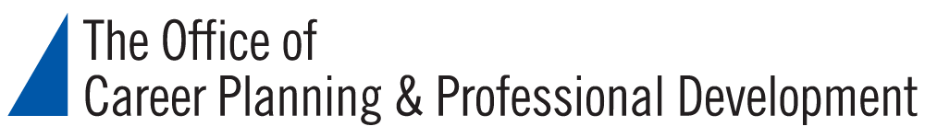

How to Find the Right Internship for You
Resources

The Office of Career Planning & Professional Development

- Home Page: https://careerplan.commons.gc.cuny.edu/
- Library of Recorded Webinars: https://careerplan.commons.gc.cuny.edu/services/webinars

Potential Funding Sources

- Altfest Internship: See information in GC Connect https://careerplan.commons.gc.cuny.edu/services/appointments
- GC library databases for finding grants and funding: http://libguides.gc.cuny.edu/grants
- Online resources for scholarships and grants
  - Scholarships.com: https://www.scholarships.com/
  - Foundation Grants to Individuals Online: https://grantstoindividuals.org
  - Unigo.com: https://www.unigo.com/

Finding Internship Postings

- GC Connect: https://careerplan.commons.gc.cuny.edu/services/appointments
- Internship Websites:
  - InternshipPrograms.com: http://www.internshipprograms.com/
  - Internships.com: https://www.internships.com/
- General Job Websites:
  - Indeed.com: https://www.indeed.com/
  - LinkedIn: https://www.linkedin.com/
  - More on the OCP&PD website: https://careerplan.commons.gc.cuny.edu/resources/job-postings
- Industry-specific Job Websites:
  - Professional association websites search: https://www.livecareer.com/resources/jobs/search/professional-organizations
  - Higher Ed Jobs: https://www.higheredjobs.com/
  - Federal Government Jobs: https://www.usajobs.gov/
  - Non-profit Jobs: https://www.idealist.org/en/
  - New York Foundation for the Arts: https://www.nyfa.org/
  - Link to our website with other job postings: https://careerplan.commons.gc.cuny.edu/resources/job-postings
  - Other industry-specific website listings:
    - https://jobstars.com/niche-job-sites/
    - https://www.livecareer.com/resources/jobs/search/indres

Social Impact Career Fair

- Date: Friday, March 27, 2020
- Time: 2:30-5:00 pm
- Location: Baruch College, Newman Vertical Campus, 55 Lexington Avenue, (24th Street), 14th Floor
- https://tinyurl.com/MSPIACareerFair2020StudentReg

