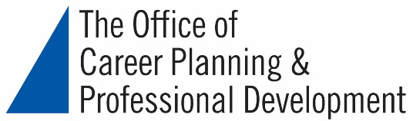

Making the Most of an Academic Conference
Webinar Resources

Resources on the Office of Career Planning & Professional Development Website:
- https://careerplan.commons.gc.cuny.edu/services (to make an appointment, access webinars and alumni aloud podcast, and sign up for our email lists)
- https://careerplan.commons.gc.cuny.edu/tools (to access GC Connect for jobs, Versatile PhD, and Vault Career Guides)
- https://careerplan.commons.gc.cuny.edu/events (check out our upcoming events)

Websites Listing Conferences and Professional Associations:
- Chronical of Higher Education: https://www.chronicle.com/
- Inside Higher Ed: https://www.insidehighered.com/
- H-Net (Humanities and Social Sciences): https://www.h-net.org/
- AAAS (American Association for the Advancement of Science): https://www.aaas.org/
- NYAS (The New York Academy of Science): https://www.nyas.org/
- ACLS (American Council of Learned Societies) Member Societies (Humanities): https://www.acls.org/Member-Societies/Society-Profiles.aspx

Covering Conference Costs:
- Student Affairs Travel Funds (will be posted in a week or two – see this area of website https://www.gc.cuny.edu/Prospective-Current-Students/Current-Students)
- PSC-CUNY Adjunct Professional Development Funds: https://www.psc-cuny.org/benefits/adjunct-cet-professional-development-fund

Fabric Posters:
https://www.spoonflower.com/

